外文翻译：
办公自动化系统
原文来源：Jorge Cardoso. Encyclopedia of Medical Devices and Instrumentation[M]. Second Edition. John Wiley&Sons. Inc. 2006. 149~157.

译文正文：
介绍
这篇文章的目的是从企业专家观点的角度来帮助某些领域如医疗保健，工程学，销售，制造业，咨询和会计的人们了解办公自动化系统。因为具有办公自动化系统的个体组织在今天的商业世界中几乎是难免的因而这显得很重要。个人电脑的广泛使用与图象驱动的操作系统的发展一道给了人们形象化和操作信息一个更加自然和更加直觉的方式。从文字处理软件到电子表格，这些应用被发展了，采取这些新的操作系统的好处，导致了人们对电脑使用的增加和对个人电脑的接受，这极大地改变了组织的处理日常业务的方式。
医疗保健企业包含跨越不同的小组和组织的复杂过程。这些过程涉及临床和管理工作、大量数据及很大数量的患者和人员。任务可以由人或自动化系统执行。在后一种情况下，这些任务是由多种软件应用程序和多个不同种类的信息系统支持和分配的。发展自动处理这些过程的系统，在提高医疗企业的效率中越来越扮演一个重要角色。
办公自动化系统（OAS）是基于计算机的，用于执行各种各样的办公操作，例如文字处理，电子表格、电子邮件和视频会议的自动化信息系统。这些不同的办公自动化系统实现了办公室内许多管理工作的自动化，通常集中在个人和集体工作的可重复性和可预测性方面。经理、工程师和职员雇员越来越频繁地使用它们来提高效率和生产力。他们支持工作者的一般活动并且强调生产办公室工作者执行的以文件为中心的任务的自动化。
OAS包含了一套广泛的能力并且为电子工作场所提供许多技术支持。OAS被集中使用于支持办公室工作者的信息和通信需要，被组织用于支持白领工作者也显示出了重要作用。
历史角度
办公自动化系统在早期集中在所有办公室的一般需求中，如阅读和写作。在50年代之前，机电和电子设备被用于执行财务和其他数字记录任务。在OAS解决方案的演变中，手工打字机被电传打字机和电子打字机替代了。
在70年代初，电子打字机是最早的办公自动化系统。它可在存储器中存储和检索信息，提供自动化功能，如居中、粗体、下划线和拼写检查。
大型机的进步发展引起了机电设备越来越多地被电脑取代。在70年代，集成电路技术使生产小型和相对低廉的个人计算机成为可能。然而，即使有这种现有技术，许多电脑公司也没有采用个人电脑。他们不能想象为什么有人当打字机和计算器就足够了时还会需要电脑。
在70年代中期，电脑开始用更复杂的方式来支持办公和组织机构。电脑的快速发展可以向市场提供先进的办公自动化设备。
70年代末，一些研究者开始描述对办公自动化系统的需求。计算机终端已取代电子打字机。随着电子技术革命的迅速发展，办公信息系统被设计成对大量信息提供存储、操纵、计算和传输的功能。第一个复杂的OAS原型包括了面向办公过程自动化的SCOOP工程和提供直观性的电子桌面，一系列操纵信息的个人生产率工具和信息共享的网络环境的Officetalk工程。
1981年， IBM公司推出了IBM PC (个人电脑)。个人电脑的诞生是一个里程碑，也证明了计算机产业不仅仅是一种趋势，而对于商界来说这些计算机是一种必要的工具。电脑被设计成仅针对文字处理和财务工作变得司空见惯。最初，个人电脑被用来取代传统的打字机和计算器，但在过去二十年里持续不断的技术进步和创新，强大的个人电脑已经成为全世界人民活动的中心。
随着个人电脑、网络、用户界面图形化和相互交流的成长和发展，给予了办公自动化系统发展的空间。例如，在1985年的Lotus Notes群件平台的推出。在此平台的应用期间，加强了群体之间的沟通、合作与协调。这个系统包含了网上讨论、电子邮件、电话书籍和文献数据库。这些年来，Lotus Notes系统在不断的改进。如今，在这个强大的合作应用平台上，这一系统包括了企业级的即时通信和调度能力的新特点。
在1992年，微软为工作组发布了新的操作系统。在现有的网络中，这种操作系统为作为客户的使用者提供了发送电子邮件和先进的联网能力。由于能够使群体合作，这是世界上最受欢迎的操作系统在巨大发展中的一个重要的阶段。微软还投资在发展完整的办公自动化系统上，在今天这些系统仍然很普遍。其中最著名和应用最广泛的软件是微软的办公软件。微软办公软件协助工人完成常见的商务工作，包括文字处理、电子邮件、幻灯片、数据管理和分析。
组织信息系统和办公自动化
当我们对办公自动化系统感兴趣的同时，有必要把它与用于组织机构中的其它信息系统联系起来。一个信息系统可以定义为一套相互关联的组件，这些组件通过对信息进行取出、操作、储存和描述来支持组织中的决策和管理。信息系统所扮演的角色是为了协助在机构中每个级别的工人来管理资源和信息。
这篇文章主要考虑的是办公自动化系统和如何可以使它们应用在医学界。为了完整性，一些其它经常被机构使用的信息系统也被涉及。对于这种系统是如何开发在此没有描述，但是，对于其他的对象提供了简要描述。组织化的信息系统是一种在机构中支持几种功能及对它所支持的活动进行分类。办公自动化系统通常分为六大类型：交易处理系统，知识工作系统，办公自动化系统，管理信息系统，决策支持系统和执行信息系统。这些系统在图1中被列举。
区分组织中某个特定应用或系统使用的目的或层次是很重要的。例如，交易处理系统，用来记录日常交易并提供资料供其他系统使用，而办公自动化系统着眼于数据人员通过应用如文字处理、电子信件等应用程序来提高生产率。
交易处理系统(TPS) ：用于对组织至关重要的日常交易，例如：订单处理、发薪、会计、制造和记录。
办公自动化系统(OAS) ：帮助办公人员处理和管理文件、日程表、电子邮件、会议和通讯过程。提取职工数据信息的过程，而不是创造信息，主要是牵涉到信息的使用、操纵或传播。
知识工作系统(KWS) ：数据人员处理信息及它在组织内的传播和整合。一般而言，知识工作者拥有专业资格(例如，工程师，经理，律师，分析师) 。
管理信息系统(MIS) ：给中级管理者提供由部下的TPS产生的包含组织基本操作的报告。通常，这些系统注重内部活动，提供信息和短期规划与决策。
决策支持系统(DSS) ：着重帮助管理人员从半结构或非结构化信息中作出决定。这些系统所使用的内部资料来自TPS和MIS系统，但也有来自外部数据源的信息，提供工具支持假设分析的设定。
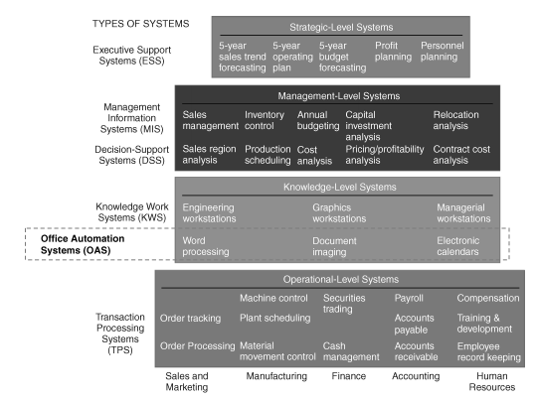
图1 信息系统的种类
执行信息系统(EIS ) ：支持高级和顶层管理人员。它们从内部和外部事件中获取数据，如新的法律、税法及内部MIS和DSS的概括信息。EIS软件用图表显示数据以提供复杂的信息的简易表示。
办公信息系统也可以按它们所支持的组织层次进行分类。人力资源的组织工作，在不同领域和不同层次的业务是负责不同的功能且使用不同的OIS。任何组织可以视为一个多级的实体，每一级代表一个不同层次的控制，组织层次能被安排在一个金字塔中（图2）。
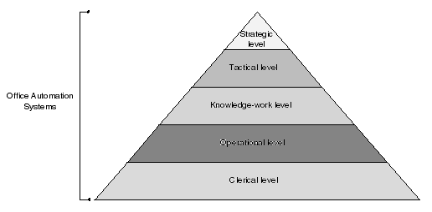
图2 支持OIS的不同组织层次
这个金字塔被划分成五个层次的部分：
职员层次：所有组织层次中支持经理的员工。
操作层次：组织中做出定期决定和应付日常操作的一线经理。
知识工作层次：经常工作在中上层的特殊领域的顾问。
战术层次：制定计划，组织和控制单位的中层管理者。
战略层次：决定事务处理方式的战略管理者。
各个相继的底层都有不同的OIS要求，及对组织有不同和不够广泛的看法。很明显，高层更加关心事务因素，在上面，他们被看成是一个具有连续数据流的同类组织。
办公自动化系统可能被有效地运用在所有职员、操作、知识工作、战术和战略水平，见图2所示。他们能协助服务与文字处理，电子邮件和报表使用，操作，发布信息，帮助管理者在计划，组织，控制和采取决策。
办公自动化系统
典型的办公自动化系统能通过文字处理、桌面排版、文件图象和数字填充来处理和管理文件，通过电子日历进行调度安排，通过电子邮件、留言或视频会议进行通信。在这个部分，所讨论和描述的18种不同类型的OIS被分成四个类别：生产工具、数据通信系统、群件应用和电话会议系统(图3)。
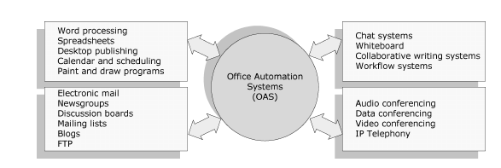
图3 办公自动化系统
生产工具
应用工具是使用软件程序制造一种成品，譬如信件、电子邮件、小册子或图象。最容易被认可的工具是文字处理程序，譬如Microsoft Word或Corel WordPerfect。其它工具帮助您查看，生成和修改一般办公室文件譬如信件、报表、备忘录、介绍和图象。
文字处理。在所有计算机应用中，文字处理是最普遍的。基本上所有的计算机都有一个文字处理工具：它是否独立于操作系统或是否分开地被购买了。
为了执行文字处理，需要具备计算机、文字处理软件和打印机。一个文字处理器可以让您创建文件，保存，在计算机屏幕上显示，修改它和使用打印机打印它。有许多不同的文字处理程序可利用，它提供了不同的工具使得从写信和学期论文到编写网页变得更加的容易了。
多数人使用文字处理软件而不是一台打字机，因为它允许更加巨大的灵活性和控制性。它允许对文件作出改动而不是对整个文件重新打印。如果当键入文本时犯了错误，游标可以用来改正错误。文字处理软件允许文本重新整理，改变布局，格式化文本，插入图片、表格和图表。
现在的文字处理软件不仅仅是可以创建和编辑文档，它在格式化的文件中具有很大的作用。下列是文字处理软件的主要特点：
插入、删除、拷贝、剪切和粘贴文本：允许在文档中的任何地方插入、删掉和复制文本。剪切和粘贴允许一段文本从一个地方移动到另一个地方及把它插入到文档中的其他某处。
查找和替换：允许查找一个特定的词并可以替换这组词。
字体规格：允许改变文档内的字体。例如，您能指定粗体、斜体、字体大小和下划线。
图象：可以在文档中加入图片。
标题和交叉引用：可以添加字幕来描述图表，并在文档中的任何地方引用它们。
页面设置，页眉和页脚：页边距和页面长度能够随意调整。可以指定定制的由文字处理器放在每页的顶部和底部的页眉和页脚。
布局：可以在单个文档中指定不同的页边距及为段落凹进指定不同的方法。
分类检查和词库：拼写检查设备能够检查和修改拼写。词库可以搜索同义词。
目录和索引：可以创建目录和索引。
打印：允许发送文件到打印机得到硬拷贝。
电子表格。电子表格是一个在行和列的格子中列出数据如数字和文本的电脑程序。这个网格被称为是一个工作表。你能在每个单元中定义数据类型和单元间彼此依赖的差异。单元间的关系称为公式，这些单元名叫标签。市场上有很多表单应用程序，Lotus和微软的Excel是最有名的。在Excel中，多个表单被称为工作簿，一个工作簿包含多个工作表单。一个Excel工作表单的示例如图4所示。
桌面排版。桌面排版是利用计算机和专业软件为桌面或商业打印创造高质量的文件。排版的过程就是编辑和排版将出版的印刷材料，如用一台个人电脑处理图书、杂志、小册子和传单。
随着Aldus PageMaker软件的商品化，桌面出版工作开始于1985年。现在有很多软件程序供排版，QuarkXPress、Adobe InDesign、Abobe PageMaker和Microsoft Publisher是应用最广的。
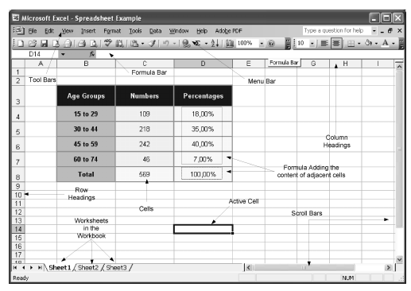
图4 微软Excel表格程序
图5显示了用Microsoft Publisher创建和编辑文档。
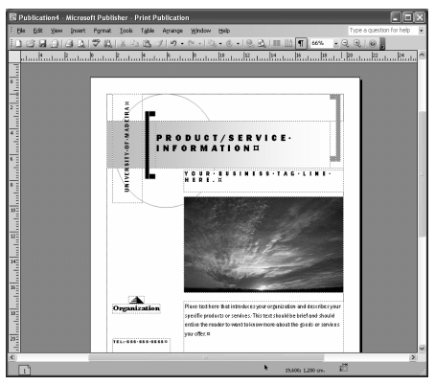
图5 Microsoft Publisher编辑文档
随着文字处理程序变得更为复杂，桌面出版系统的区分正变得模糊。最尖端的文字处理程序给出了一个桌面出版程序的大部分特征。这些程序一般不替换文字处理软件和图表应用，而被用于集合这些程序中创建的文字和图象内容。最强大的桌面出版系统，能够创建插图；而不太强大的系统只能插入由其他程序创建的插图。最初的桌面排版解决方案都是非常昂贵的，由于使用专门的计算系统和配件，如打印机和扫描器。计算机和打印机的成本近几年急剧下降（例如，喷墨打印机惊人的便宜和大部分都可以彩色打印），让个人用户获得了桌面出版系统。
日历和日程安排。日历程序能使我们在电子日历上记录事件和安排。日历可以进行安排，项目管理和协调许多人，并能为调度设备提供支援。典型特征能识别时刻表中的冲突，找出每个人的会议时间，提醒即将发生的事情，自动填写日常事务中的条目。日历调度程序是一类特殊的日历，它是管理安排日常事务需要的解决方案，如安排约会、设备、人员（技术员、专家，医疗保健工作者，其他）、车辆、资源、项目和会议室。调度软件是任何事务类型想要改善调度过程的的一种重要的投资。每个雇员都可以即时获得在一天，一周，一月，一年内的可用资源，并打印详细清单报告。当然，也有可能输出可轻易打开一个文字处理软件或电子表格的时刻表。
绘图程序。绘图程序能够创建图片，背景，按钮，线条和其他创造性的艺术。绘图程序提供了画相同形状的图形如直线，矩形，圆和椭圆的简易方法。一些程序也有图片编辑能力和对特定种类的图象如照片的优化工作，但大多数较小的绘图程序不具有这个选项。绘图程序是基于象素的，使用称为象素的小圆点组成的"栅格"图像。由于每个小圆点是单独的，在屏幕附近移动形状可以是难的。
绘画程序不同于绘图程序。绘画程序基于有几何形状的对象，例如直线、圆、曲线、矩形、多边形或者Bezier曲线(在任何时候可以通过改变角度且沿着长度变化钩状的曲线)。在绘画程序中，图像是以直线或者任何一种曲线的向量的这种数学的信息载体来存储的。一些程序经常混淆绘图和绘画的区别，因此可以找到同时兼容这两种工作的程序。
数字通信系统。如今，越来越多的电脑不是孤立存在的，而是通过网络连接在一起，如同所有的电话连在一起。如果连接在同一个网络的电脑，人们可以通过该网络相互交流。
电子邮件。电子邮件、电子邮箱、或者电子短信(一种较常见的拼写电子邮件的方法)是在Internet上非常流行的通信方式。这些都是人们相互之间通信的简单工具。大多数大型机、小型机和计算机网络都拥有E-Mail系统。
电脑传送邮件信息时，通过电子邮件地址标示要传送对象的目的地址。包含两部份：用户名，邮件域或者域名。用户名确定一个特定的用户，邮件域用来确定邮件传送对象在Internet上的地点。读邮件地址时，应该从左向右。例如图6。
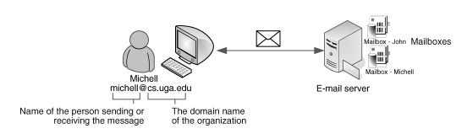
图6 邮件地址结构
同一个电子邮件帐户，有可能将信息传送给任何具有电子邮件帐户的用户。正如一封亲笔信可以有多个接受者，电子邮件信息也可以向多个邮件地址发送。一个电子邮件可以细分为若干个基本领域，包括“From”，“To”，“Cc”。“From”是发送人的地址信息，“To”可以包括一个或者多个主要接收人的地址信息，所有的接收人在字段中列出。“Cc”域(Cc 即Corban copy)中包括的不是主要接收人的地址信息。
电子邮件信息并不只限于文字，其他类型的文件可以列为电子邮件的附件。附件可以是文本文件也可以是二进制文件，例如字处理文件、电子表格、图像、声音视频文件和软件。要查看是否有电子邮件，你可以定期检查电子邮箱，当然也可以设置当有新的E-Mail时自动提醒用户。当你看完一封电子邮件时，你可以选择保存、删除、回复、转发给他人或打印出来。

外文原文：

OFFICE AUTOMATION SYSTEMS

INTRODUCTION
The purpose of this article is to help people in fields, such as healthcare, engineering, sales, manufacturing, consulting, and accounting to understand office automation systems from the viewpoint of a business professional. This is important because personal association with office automation systems is almost unavoidable in today’s business world. The widespread adoption of personal computers in conjunction with the development of graphically driven operating systems gave people a more natural and intuitive way of visualizing and manipulating information. The applications that were developed, from word processors to spreadsheets, to take benefit of these new operating systems, led to a growth in the use and acceptance of personal computers that significantly altered the manner organizations conduct their daily business.
Healthcare enterprises involve complex processes that span diverse groups and organizations. These processes involve clinical and administrative tasks, large volumes of data, and large numbers of patients and personnel. The tasks can be performed either by humans or by automated systems. In the latter case, the tasks are supported by a variety of software applications and information systems that are very often heterogeneous, autonomous, and distributed. The development of systems to manage and automate these processes has increasingly played an important role in improving the efficiency of healthcare enterprises.
Office Automation Systems (OAS) are computer-based automated information systems that are used to execute a variety of office operations, such as word processing, electronic spreadsheet, e-mail, and video conferencing. These different office automation systems allow the automation of much of the administrative work in the office and typically focuses on the more repeatable and predictable aspects of individual and group work. They are more and more frequently used by managers, engineers, and clerical employees to increase efficiency and productivity. They support the general activities of workers and underlie the automation of document-centric tasks performed by production office workers.
The OAS encompasses a broad set of capabilities, and provides much of the technological basis for the electronic workplace. The focus of OAS have typically been used in supporting the information and communication needs of office workers, and its use by organizations supporting the white-collar work force has revealed itself crucial.

HISTORICAL PERSPECTIVE
In its early days, office automation systems focused on needs generally found in all offices, such as reading and writing. Before the 1950s, electromechanical and electronic devices were used to carry out financial and other numerical record-keeping tasks. During the evolution of OAS solutions, manual typewriters have been replaced by the electric typewriter and the electronic typewriter.
The electronic typewriter, introduced in the early 1970s, was the first of the automated office systems. It could store and retrieve information from memory providing automated functions such as center, bold, underline, and spell check.
The advances in the development of mainframes have caused electromechanical devices to be increasingly replaced by computers. In the 1970s, integrated circuit technology made the production of small and relatively inexpensive personal computers possible. Yet, even with this available technology, many computer companies chose not to adopt personal computers. They could not imagine why anyone would want a computer when typewriters and calculators were sufficient.
In the mid-1970s, computers began to support offices and organizations in more complex ways. The rapid growth of computers furnished the market with sophisticated office automation devices.
In the late 1970s, several researchers started to describe the needs of office automation systems. Computer terminals had replaced electronic typewriters. With the rapid evolution of electronic technology, office information systems were developed to provide for the storage, manipulation, computation, and transmission of large amounts of information. The first sophisticated OAS prototypes included the SCOOP project, which was oriented to the automation of office procedures, and Officetalk, which provided a visual electronic desktop metaphor, a set of personal productivity tools for manipulating information, and a network environment for sharing information.
In 1981, IBM introduced the IBM PC (Personal Computer). The PC was a milestone and proved that the computer industry was more than a trend, and that the computer was in fact a necessary tool for the business community. Computers, designed solely for word processing and financial tasks, became common. At first, the PC was utilized to replace traditional typewriters and calculators, but persistent technological advances and innovation over the past two decades have put powerful PCs at the center of daily activities for people worldwide.
The growth and widespread adoption of PCs, networks, graphical user interfaces, and communications as allowed the development of complete OAS package suites. For example, in 1985 the Lotus Notes groupware platform was introduced. The term groupware refers to applications that enhance communication, collaboration, and coordination among groups of people. This system included online discussion, e-mail, phone books, and document databases. Throughout the years, continuous improvements were made to Lotus Notes. Nowadays, this system includes new features, such enterprise-class instant messaging, calendaring, and scheduling capabilities with a strong platform for collaborative applications.
In 1992, Microsoft lunched its new operating system (OS), Microsoft for Workgroups. This OS allowed the sending of electronic mail and provided advanced networking capabilities to be used as a client on existing networks. This was an important stage in the vast evolution of the world’s most popular operating system since it enabled the collaboration of groups of people. Microsoft has also invested in the development of full OAS suites, which are commonly available nowadays. The most well-known and widespread productivity software suite is Microsoft Office. Microsoft Office helps workers to complete common business tasks, including word processing, e-mail, presentations, data management and analysis.

ORGANIZATIONAL INFORMATION SYSTEMS AND OAS
While we are interested in studying office automation systems (OAS), it is important to relate this type of systems with other information systems (IS) commonly used inside an organization. An information system can be defined as a set of interrelated components that retrieve, process, store and distribute information to support decision making and control in an organization. The main role of IS is to assist workers in managing resources and information at each level in the organization.
This article is primarily concerned with OAS and how they can be used in the medical community. For completeness, some other types of information systems commonly used by organizations are also mentioned. There will be no description of how such systems are developed, however, a brief description of their objectives will be given. Organizational information systems (OIS) are systems that support several functions in an organization and can be classified by the activity that they support. The OIS are usually split into six major types: Transaction Processing System, Knowledge Work Systems, Office Automation System, Management Information System, Decision Support System, and Executive Information System. These systems are illustrated in Fig. 1.

Figure 1. Types of information systems
It is important to be able to distinguish the objectives and the level in the organization where a particular application or system can be used. For example, Transaction Processing Systems are employed to records daily routine transactions to produce information for other systems, while Office Automation Systems are oriented to increase that productivity of data workers using applications such as word processing and electronic mail applications.
Transaction Processing System (TPS): Is useful for daily transactions that are essential to the organization such as order processing, payroll, accounting, manufacturing, and record keeping.
Office Automation System (OAS): Aids office workers in the handling and management of documents, schedules, e-mails, conferences and communications. Data workers process information rather than create information and are primarily involved in information use, manipulation or dissemination.
Knowledge Work System (KWS): Promotes the creation of new information and knowledge and its dissemination and integration within the organization. In general, knowledge workers hold professional qualifications (e.g., engineers, managers, lawyers, analysts).
Management Information System (MIS): Provides middle-level managers with reports containing the basic operations of the organization which are generated by the underlying TPS. Typically, these systems focus on internal events, providing the information for short-term planning and decision making.
Decision Support System (DSS): Focuses on helping managers to make decisions from semi structured or unstructured information. These systems use internal information from TPS and MIS, but also information from external data sources, providing tools to support ‘what-if’ scenarios.
Executive Information System (EIS): Supports senior and top-level managers. They incorporate data from internal and external events, such as new legislation, tax laws, and summarized information from the internal MIS and DSS. EIS software displays data graphically to provide easy-to-use representations of complex information.
Office information systems can also be classified by the organizational level they support. The human resources of an organization work in different areas and levels of operations are in charge of different functions, and use different OIS. Any organization can be viewed as a multilevel entity with each level representing a different level of control. The levels of an organization can be arranged in a pyramid (Fig. 2).

Figure 2. Support of OIS to the different organizational levels
The pyramid is divided into five horizontal sections:
Clerical level: Employees who support managers at all levels of the organization.
Operational level: First-line managers who make routine decisions and deal with the day-to-day operations of the organization.
Knowledge-work level: Advisors to both top and middle management who are often experts in a particular area.
Tactical level: Middle managers who deal with planning, organizing and the control of the organization.
Strategic level: Strategic managers who make decisions that guide the manner in which business is done.
Each successively lower level has different OIS requirements and a different, and less extensive, view of the organization. Obviously, the higher the level, the more interrelated the business functions become until, at the very top, they are viewed as one homogeneous organization with one continuous data flow.
Office automation systems can be effectively utilized in all the clerical, operational, knowledge-work, tactical, and strategic levels, as illustrated in Fig. 2. They can assist workers who work with word processors, electronic mail, and spreadsheets to use, manipulate, disseminate information, and help managers in planning, organizing, control and taking decisions.

OFFICE AUTOMATION SYSTEMS
Typical office automation systems handle and manage documents through word processing, desktop publishing, document imaging, and digital filing, scheduling through electronic calendars, and communication through electronic mail, voice mail, or video conferencing. In this section, 18 different types of OIS are discussed and described that are classify into four categories: productivity tools, digital communication systems, groupware applications, and teleconferencing systems (Fig. 3).

Figure 3. Office information systems

Productivity Tools
Productivity tools are software programs used to create an end product, such as letters, e-mails, brochures, or images. The most easily recognized tool is a word processing program, such as Microsoft Word or Corel WordPerfect.
Other tools help you view, create and modify general office documents such as letters, spreadsheets, memos, presentations, and images.
Word Processing. Of all computer applications, word processing is the most common. Almost every computer has a word processing program of some kind: whether it came free with the operating system or whether it was purchased separately.
In order to perform word processing, it is necessary to acquire a computer, a word processor, and a printer. A word processor enables you to create a document, store it, display it on the computer screen, modify it, and print it using a printer. There are many different word processing programs available, each offering different tools that make it easier to write everything from letters and term papers to theses and Web pages.
Most people use a word processor rather than a type-writer because it allows greater flexibility and control. It is possible to make changes without retyping the entire document. If mistakes are made while typing a text, the cursor can be used to correct errors. Word processors allow text rearranging, changing the layout, formatting the text, and inserting pictures, tables, and charts.
Most word processors available today allow more than just creating and editing documents. They have a wide range of other tools and functions, which are used in formatting documents. The following are the main features of word processors:
Insert, delete, copy, cut, and paste text: Allow to insert, erase, and copy text anywhere in the document. Cut and paste allow removing (cut) a section of text from one place and inserting (paste) it somewhere else in the document.
Search and replace: Allow searching for a particular word and also replacing groups of characters.
Font specifications: Allow to change fonts within a document. For example, you can specify bold, italics, font size and underlining.
Graphics: Allow adding pictures into a document. Captions and cross-references: Allow placing captions to describe tables and pictures and creating references to them anywhere in the document.
Page setup, headers, and footers: Margins and page length can be adjusted as desired. Allow to specify customized headers and footers that the word processor will put at the top and bottom of every page.
Layout: Allows specifying different margins within a single document and to specify various methods for indenting paragraphs.
Spell checker and thesaurus: Spelling can be checked and modified through the spell check facility. The thesaurus allows the search for synonyms.
Tables of contents and indexes: Allow creating table of contents and indexing.
Print: Allows sending a document to a printer to get a hardcopy.
Spreadsheet. A spreadsheet is a computer program that presents data, such as numbers and text, in a grid of rows and columns. This grid is referred to as a worksheet. You can define what type of data is in each cell and how different cells depend on one another. The relationships between cells are called formulas, and the names of the cells are called labels.
There are a number of spreadsheet applications on the market, Lotus 1-2-3 and Microsoft Excel being among the most famous. In Excel, spreadsheets are referred to as workbooks and a workbook can contain several worksheets. An example of an Excel worksheet is shown in Fig. 4.
Desktop Publishing. Desktop publishing is the use of the computer and specialized software to create high quality documents for desktop or commercial printing. Desktop publishing is the process of editing and layout of printed material intended for publication, such as books, magazines, brochures, and flyers using a personal computer.
Desktop publishing started in 1985, with the commercialization of the software Aldus PageMaker. Nowadays, there are many software programs available for desktop publishing. QuarkXPress , Adobe InDesign , Abobe PageMaker , and Microsoft Publisher are the most widespread. Figure 5 shows a document being created and edited with Microsoft Publisher.

Figure 4. Microsoft Excel spreadsheet program
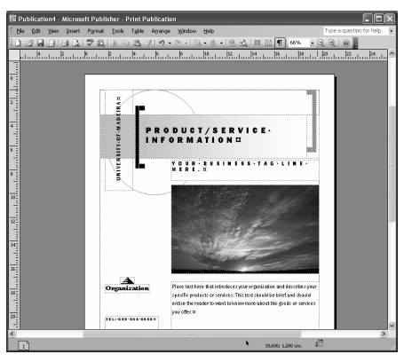

Figure 5. Editing a document with Microsoft Publisher
As word processing programs become more sophisticated, the line separating such programs from desktop publishing systems is becoming fuzzy. Cutting-edge word processing programs give you most of the features you could want in a desktop publishing program. Such programs do not generally replace word processors and graphic applications, but are used to aggregate the text and graphic content created in these programs. The most powerful desktop publishing systems enable the creation of illustrations; while less powerful systems let you insert illustrations created by other programs.
Initial desktop publishing solutions were expensive due to the cost of specialized computing systems and accessories, such as printers and scanners. The cost of computers and printers has fallen dramatically in recent years (e.g., inkjet printers are amazingly inexpensive and most can print in color), allowing most personal users to acquire desktop publishing systems.
Calendars and Schedulers. A calendar program enables us to record events and appointments on an electronic calendar. Calendars allow scheduling, project management, and coordination among many people, and may provide support for scheduling equipment as well. Typical features identify conflicts in schedules, find meeting times that will work for everyone, signal upcoming events, and automatically fill in entries for regular events.
A special type of calendar, called a scheduler, is a solution to manage the daily scheduling needs of a business, such as scheduling appointments, equipment, staff (technicians, professionals, healthcare workers, others), vehicles, resources, projects, and meeting rooms. Scheduling software is an important investment for any type of business that wants to improve its scheduling processes. Every employee can have instant access to whom or what is available at any time of the day, week, month, or year and print detailed list reports. It is also possible to export schedules that may be easily opened in a word processor or spreadsheet.
Paint and Draw Program. A paint program or a graphics program enables the creation of pictures, backgrounds, buttons, lines, and other creative art. Paint programs provide easy ways to draw common shapes, such as straight lines, rectangles, circles, and ovals. Some programs also have photo editing capabilities and are optimized for working with specific kinds of images, such as photographs, but most of the smaller paint programs do not have this option. Paint programs are pixel based. They use ‘‘raster’’ images made up of small dots called pixels. As each dot is an individual, it can be difficult to move shapes around the screen.
A draw program is different from a paint program. Draw programs are object based, where an object is a geometrical shape, such as a line, a circle, a curve, a rectangle, a polygon, or a Bezier curve (curves that have hooks along their length so you can alter the angle of the curve at any point.) With draw programs, images are stored as mathematical information in the form of vectors for the lines and curves of each shape. Sophisticated programs often blur the difference between draw and paint, so it is possible to find programs that are able to do both types of work.
Digital Communication Systems. Nowadays, more and more computers are not isolated but, instead, are connected into a computer network that is often connected to other computer networks in much the same way as telephone systems connect telephones. If a computer is connected to such a network, it is possible to communicate with people whose computers are connected to the same network.
Electronic Mail. Electronic mail, or e-mail for short (another common spelling for e-mail is email), is one of the most popular uses of the Internet. It is a simple tool for exchanging brief messages between individuals or among a larger audience. Most mainframes, minicomputers, and computer networks have an e-mail system.
An e-mail address identifies a person and the computer for purposes of exchanging electronic mail messages. It consists of two parts: user name and mail domain or domain name. The user name identifies a particular person. The mail domain identifies the place on the Internet to which the e-mail for that person should be sent. An e-mail address is read from left to right. An example is illustrated in Fig. 6.
With an e-mail account, it is possible to send a message to anyone with an e-mail account. Just as a written letter can be sent to multiple recipients, an electronic mail message can be sent to one or more e-mail addresses. An e-mail can be broken down into several basic fields that include ‘From’, ‘To’, and ‘Cc’. The ‘From’ field contains the address of the sender of the message. The ‘To’ field indicates the addresses of one or more recipients who are the primary audience. All recipients can see every address listed in this field. Finally, the ‘Cc’ field (Cc - Carbon Copy) contains the addresses of recipients how are not the primary audience for the e-mail.

Figure 6. E-Mail address structure
An electronic mail message is not limited to text. Other types of files can be added to mail messages as attachments. Attachments can be text files or binary files such as word processed documents, spreadsheets, images, files of sound and video, and software. To see if you have any e-mail, you can check your electronic mailbox periodically, although many programs can be configured to alert users automatically when mail is received. After reading an e-mail, it may be stored, deleted, replied to, forwarded to others, or printed.

